             AWS interview qns

1.what is the difference between NAT gate way and internet gateway?

A NAT device forwards traffic from the instances in the private subnet to the internet or other AWS services, and then sends the response back to the instances while Internet Gateway is used to allow resources in your VPC to access internet

2. what is the difference b/w security group and NACL?

Security groups are associated with an instance of a service. It can be associated with one or more security groups which has been created by the user. **NACL can be understood as the firewall or protection for the subnet.** **Security group can be understood as a firewall to protect EC2 instances**.

3.what is the elastic IP ?

An Elastic IP address is **a reserved public IP address that you can assign to any EC2 instance in a particular region, until you choose to release it**. To allocate an Elastic IP address to your account in a particular Region, see Allocate an Elastic IP address.

4.what are the placement groups in EC2?

**Cluster**

**Partition**

**Spread**

**5.what is cluster,spread and partition?**

* **Cluster** – packs instances close together inside an Availability Zone. This strategy enables workloads to achieve the low-latency network performance necessary for tightly-coupled node-to-node communication that is typical of high-performance computing (HPC) applications.
* **Partition** – spreads your instances across logical partitions such that groups of instances in one partition do not share the underlying hardware with groups of instances in different partitions. This strategy is typically used by large distributed and replicated workloads, such as Hadoop, Cassandra, and Kafka.
* **Spread** – strictly places a small group of instances across distinct underlying hardware to reduce correlated failures.

**6.what is network interface in aws?**

AWS Network Interface or Elastic Network Interfaces (AWS ENIs) are **virtual network cards attached to EC2 instances that help facilitate network connectivity for instances**. Having two or more of AWS Network Interface connected to an instance permits it to communicate on two separate subnets.

**7.what Is the difference b/w vpc peering and transit gateway?**

TGWs across different regions can peer with each other to enable VPC communications across regions. Each spoke VPC only needs to connect to the TGW to gain access to other connected VPCs. **provides simpler VPC-to-VPC communication management over VPC Peering with a large number of VPCs**

**Ip not overlapped**

**8.what is the difference b/w s3 ,ebs,efs?**

Interface: **S3 provides you a web interface while EBS provides a file system interface and EFS provides a web and file system interface**. Storage Type: AWS S3 is object storage while Amazon EBS is block storage and Amazon EFS is file storage.

9. What is a VPC endpoint used for?

VPC endpoints can **improve network security**

VPC endpoints also simplify infrastructure architecture. For example, you can use an interface endpoint to connect traffic from an instance to a service such as SQS, or you can: Configure an internet gateway. Configure security group or network ACL rules.

**10.** How many storage classes are there in S3?

S3 Storage Classes can be configured at the object level, and a single bucket can contain objects stored across **S3 Standard, S3 Intelligent-Tiering, S3 Standard-IA, and S3 One Zone-IA**.& s3 glacier&s3 archive

**11.what is the difference IAM roles and policies?**

**IAM Roles manage who has access to your AWS resources, whereas IAM policies control their permissions**. A Role with no Policy attached to it won't have to access any AWS resources. A Policy that is not attached to an IAM role is effectively unused.

12.what is usecase of permission boundaries in IAM?

A permissions boundary is an advanced feature for using a managed policy **to set the maximum permissions that an identity-based policy can grant to an IAM entity**. An entity's permissions boundary allows it to perform only the actions that are allowed by both its identity-based policies and its permissions boundaries.

13.what are the global services in aws?

Global Services—AWS Identity and Access Management (IAM), AWS Organizations, Amazon CloudFront, Amazon Route53, AWS Global Accelerator, AWS Direct Connect, AWS Firewall Manager, AWS Web Application Firewall (WAF), and AWS Shield—may store and process data globally.

14.can we rename the s3 bucket?

When you create a bucket, you choose its name and the AWS Region to create it in. After you create a bucket, **you can't change its name or Region**.

15.what is versioning in aws s3?

Versioning in Amazon S3 is **a means of keeping multiple variants of an object in the same bucket**. You can use the S3 Versioning feature to preserve, retrieve, and restore every version of every object stored in your buckets.

16.what is the use of route tables in aws?

The route table **contains existing routes with targets other than a network interface, Gateway Load Balancer endpoint, or the default local route**. The route table contains existing routes to CIDR blocks outside of the ranges in your VPC. Route propagation is enabled for the route table

17.what is vpc?

A virtual private cloud (VPC) is a secure, isolated private cloud hosted within a public cloud. VPC customers can **run code, store data, host websites, and do anything else they could do in an ordinary private cloud**, but the private cloud is hosted remotely by a public cloud provider.

18.what is applicatona & network loadbalancer?

Application Load Balancer (as the name implies) works at the Application Layer (Layer 7 of the OSI model, Request level). Network Load Balancer works at Transport layer (Layer 4 of the OSI model, Connection level).

**While a network load balancer simply forwards requests, application load balancing examines the application layer protocol data from the request header**. This examination takes more time than network load balancing, but it enables the balancer to make a more informed decision of where to direct the request.

19.what is difference b/w horizontal scaling and vertical scaling in aws?

While **horizontal scaling refers to adding additional nodes, vertical scaling describes adding more power to your current machines**. For instance, if your server requires more processing power, vertical scaling would mean upgrading the CPUs. You can also vertically scale the memory, storage, or network speed

20.what is the deregistration delay in load balancer?

Deregistration delay. Elastic Load Balancing **stops sending requests to targets that are deregistering**. By default, Elastic Load Balancing waits 300 seconds before completing the deregistration process, which can help in-flight requests to the target to complete.

21.what is the stickiness of loadbalncer?

Stickiness is a term that is used to describe the functionality of a load balancer to **repeatedly route traffic from a client to a single destination, instead of balancing the traffic across multiple destinations**.

22.what are the IAS services in AWS?

Infrastructure as a Service (IaaS) is a model that defines how vendors deliver cloud-based virtualized resources over the Internet.

IaaS is commonly contrasted with two other cloud computing patterns.

23.what are the paas in aws?

Platforms as a service remove the need for organizations to manage the underlying infrastructure (usually hardware and operating systems) and allow you to focus on the deployment and management of your applications

24.what is saas in aws?

Software-as-a-Service (SaaS) is **a business and software delivery model that enables organizations to offer their solution in a low-friction, service-centric approach**.

25. Where we can store our credentials in aws?

Basic AWS Secrets Manager scenario

The administrator also configures those credentials with the permissions required for the application to access the Personnel database. The database administrator stores the credentials as a secret in **Secrets Manager named MyCustomAppCreds** .4

26.wt is diff between the ebs & efs?

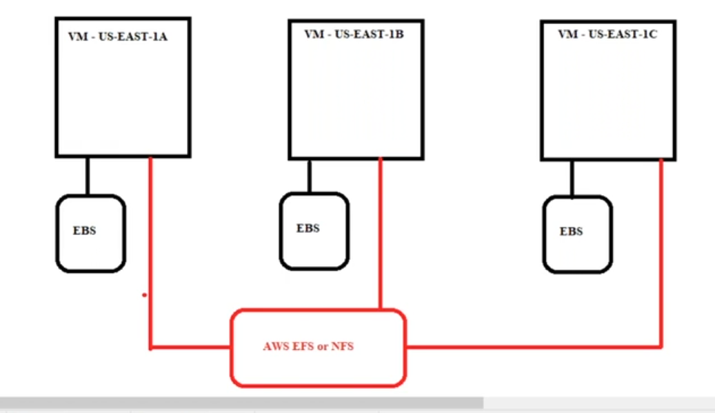

27.wt is A record in route 53?

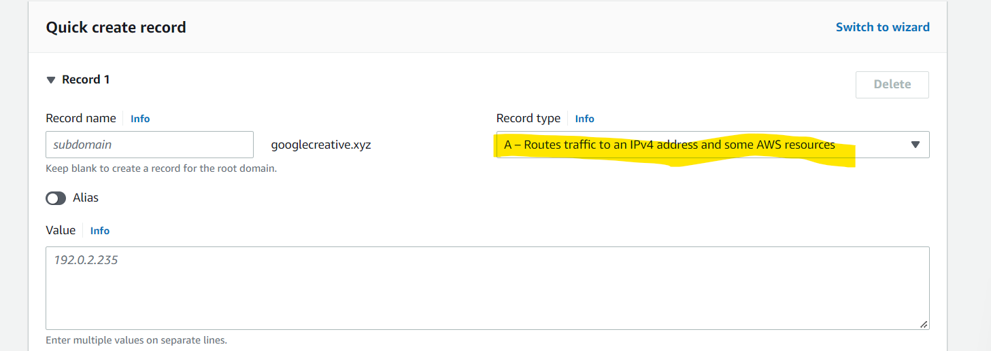

28.wt are the routing policies in route 53?

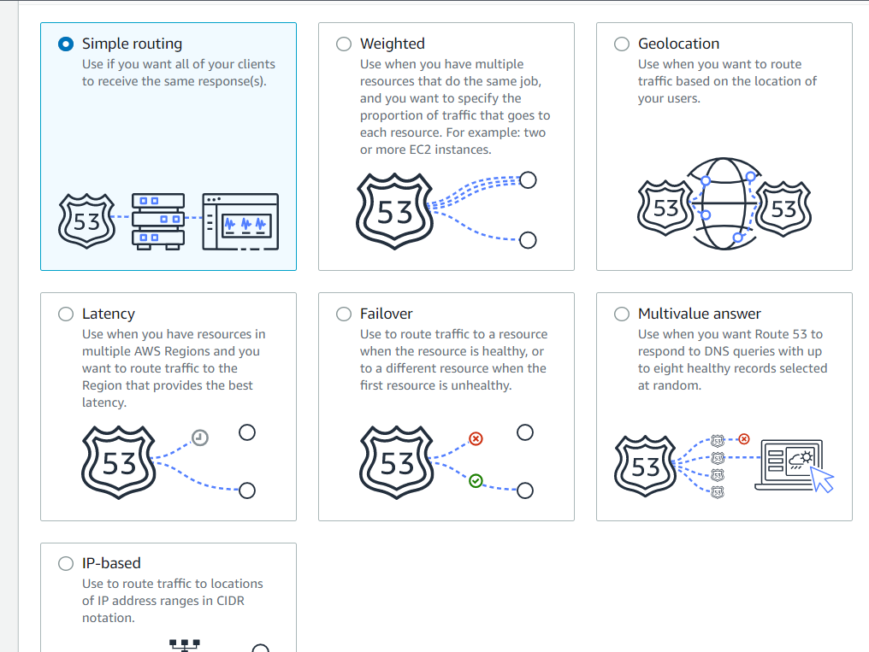

29.wt is cname records in route53?

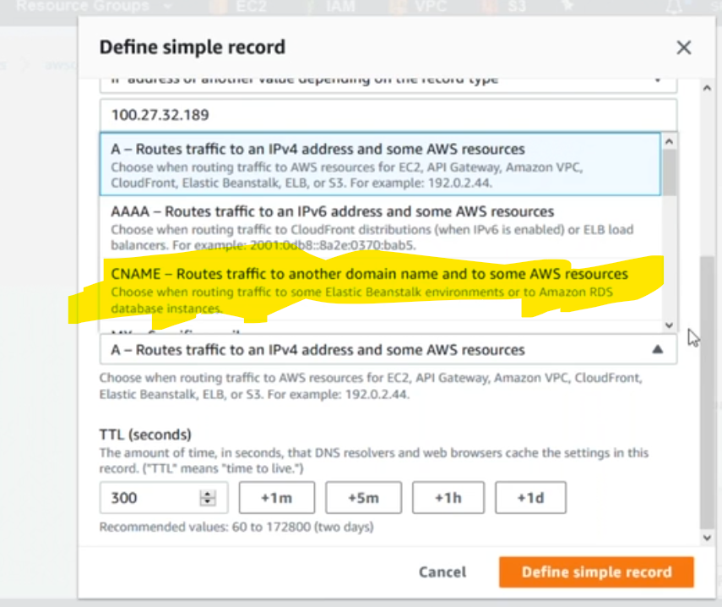

30.wt is diff between nlb vs alb?

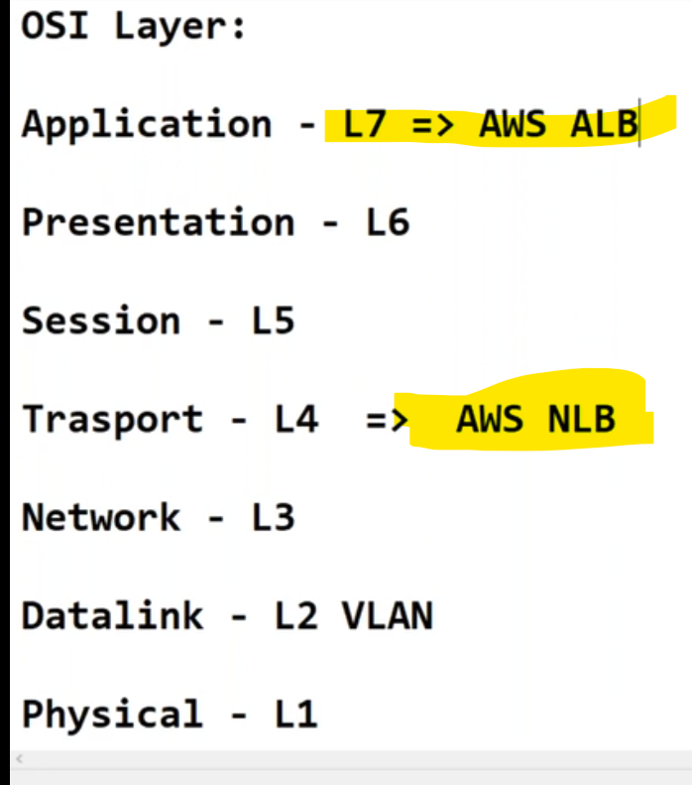

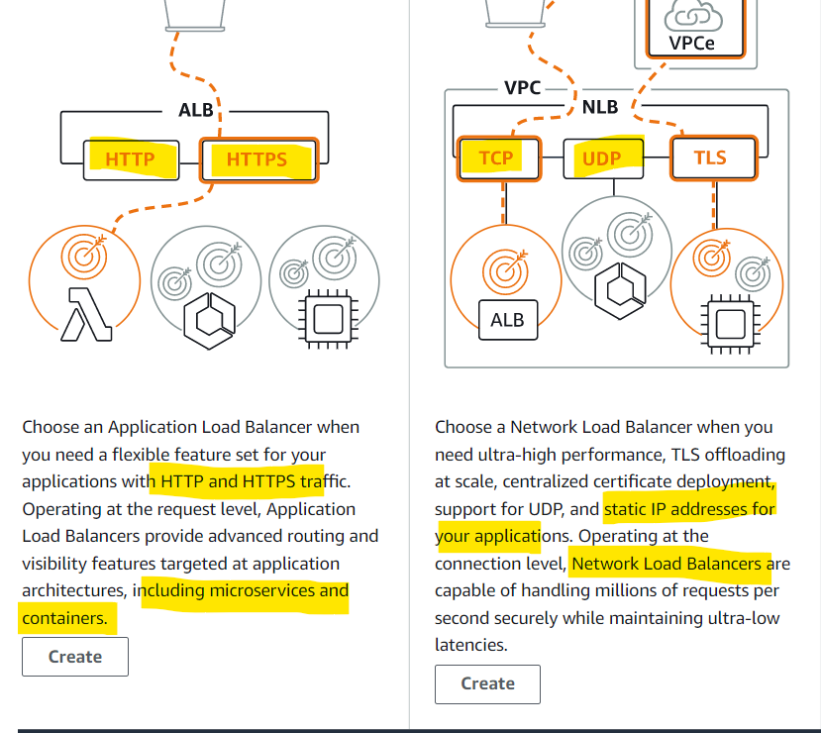

bastion host server & jump server(network servers) using for nlb,simple routing

application & data base&micro application contnaier user for alb,,

port forwarding,path based routing,

31.What is the difference between a dynamic and static IP address?

**When a device is assigned a static IP address, the address does not change.** **Most devices use dynamic IP addresses, which are assigned by the network when they connect and change over time**.

32.wt is ecs agent in ecs?

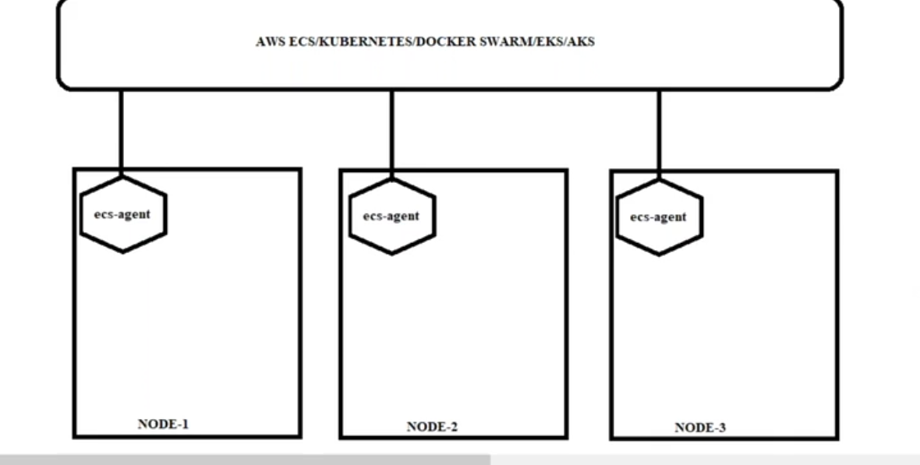

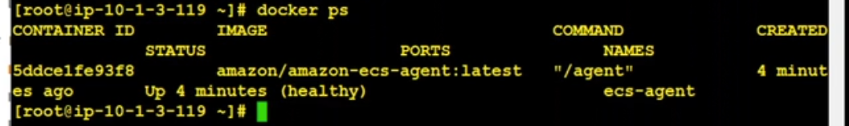

33.how to ecs-agent

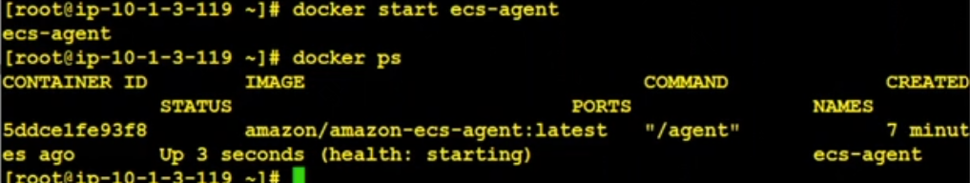34.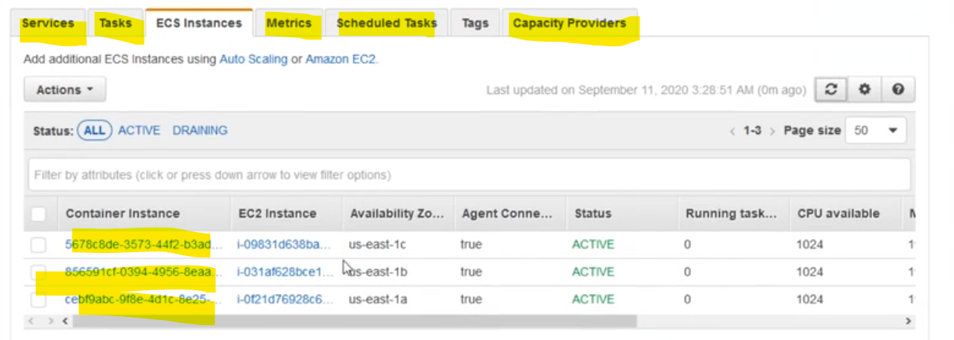

35.wt is role attch to ecs setup>?

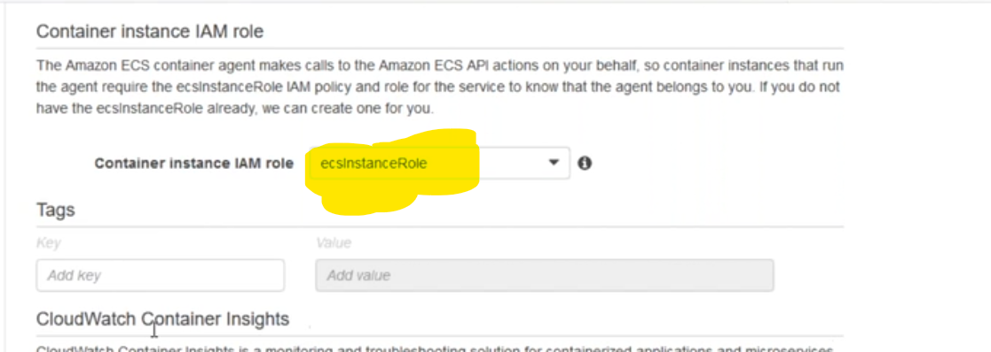

36.how to increase capacity of container in ecs?

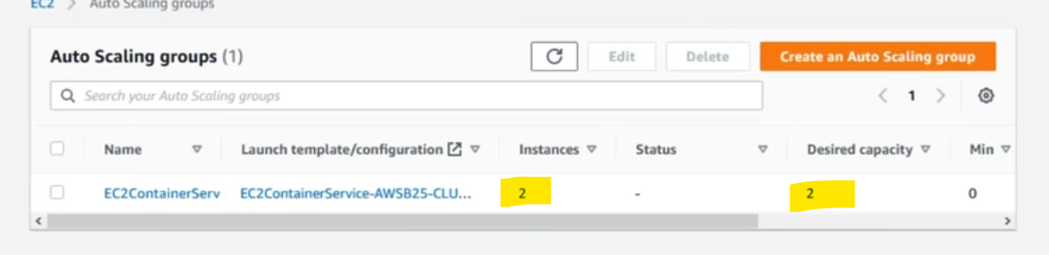

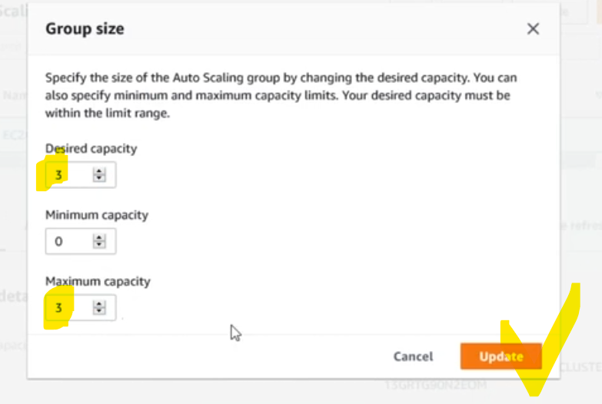

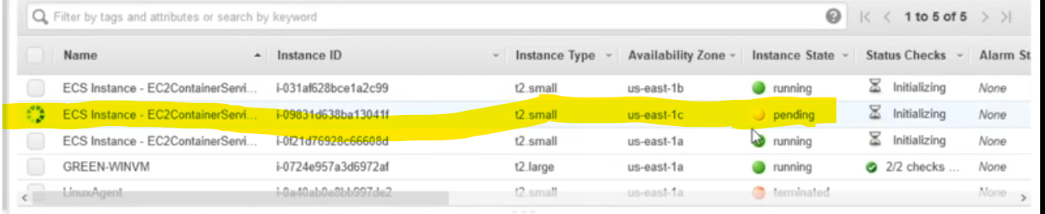

37.how to deployment in ecs?

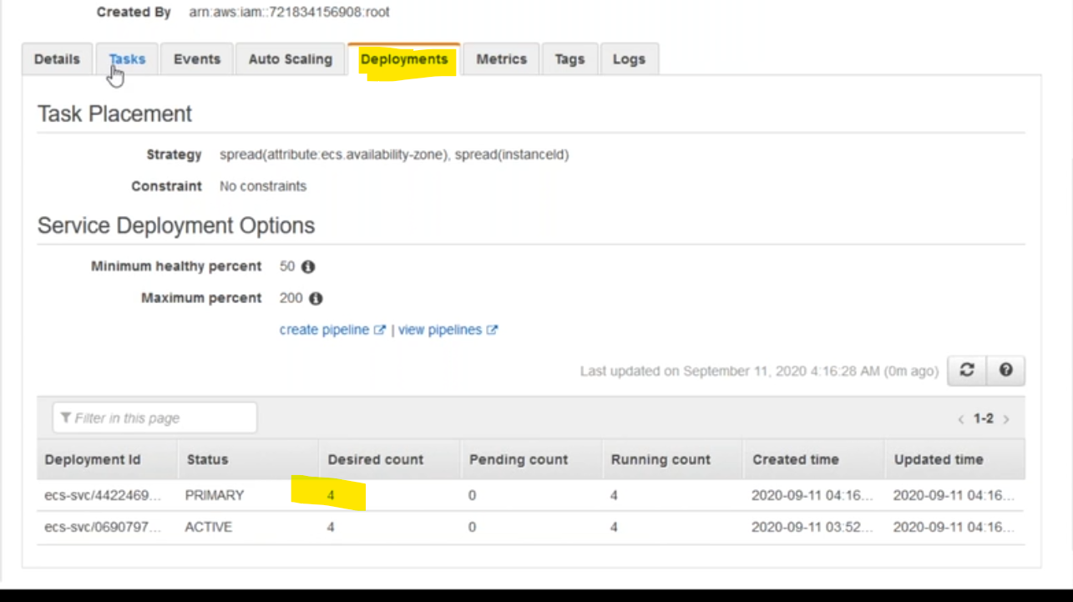

38.how to check metrics in ecs?

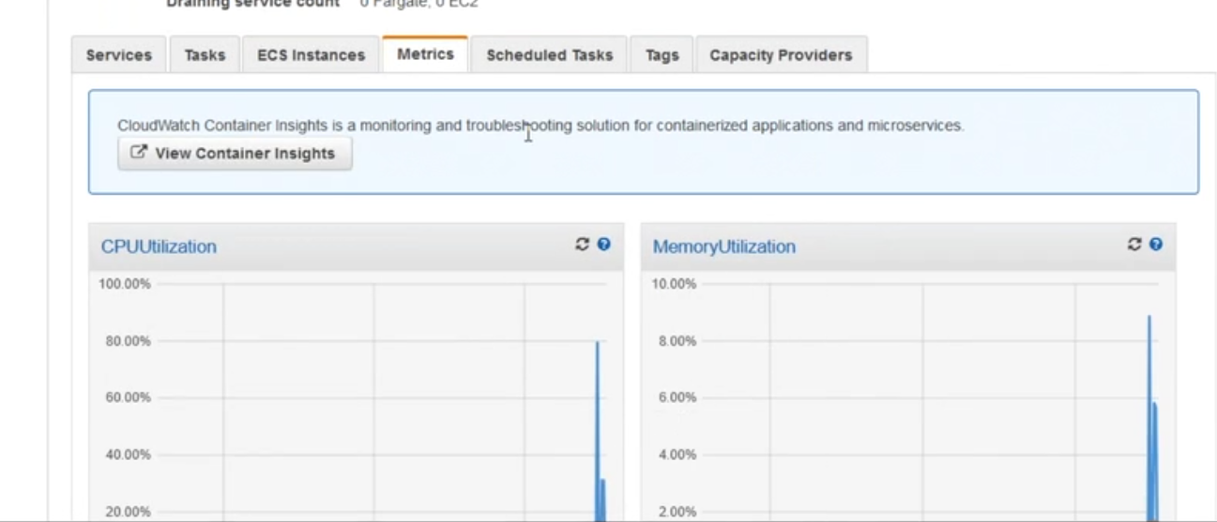

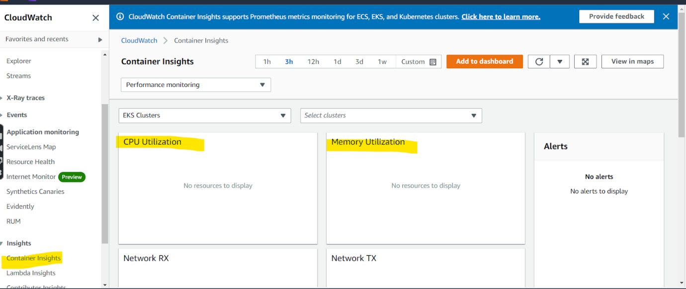

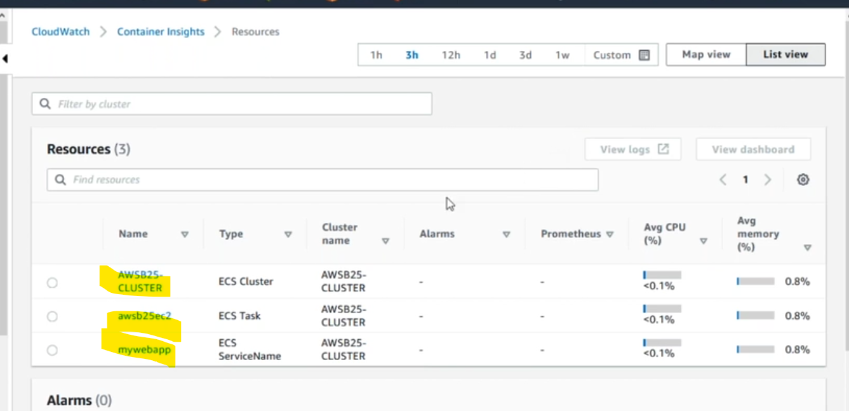

39.wt is fargate in ecs or eks?

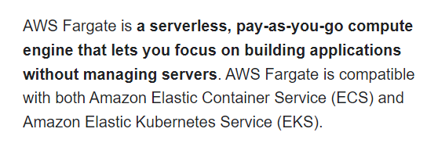

40.wt is use case of task in ecs?

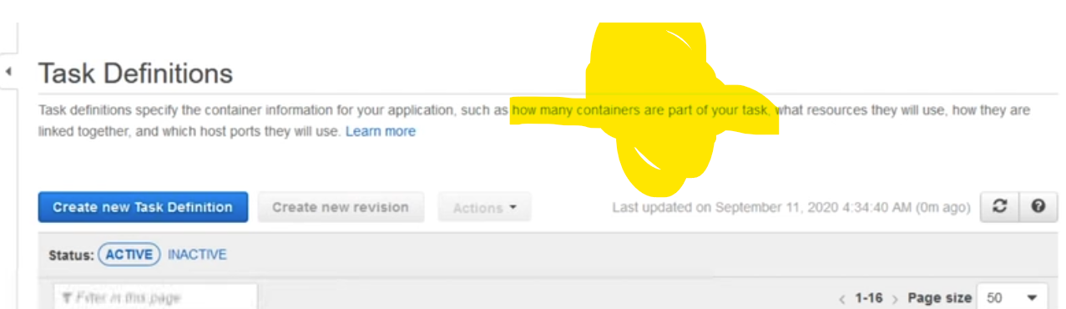

41.

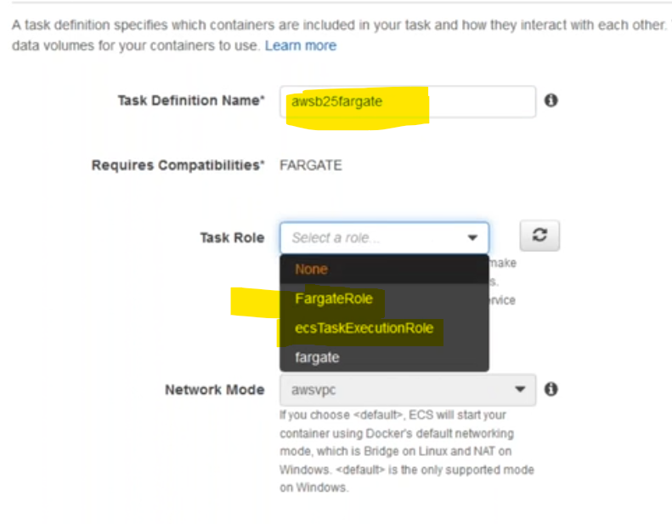

42.

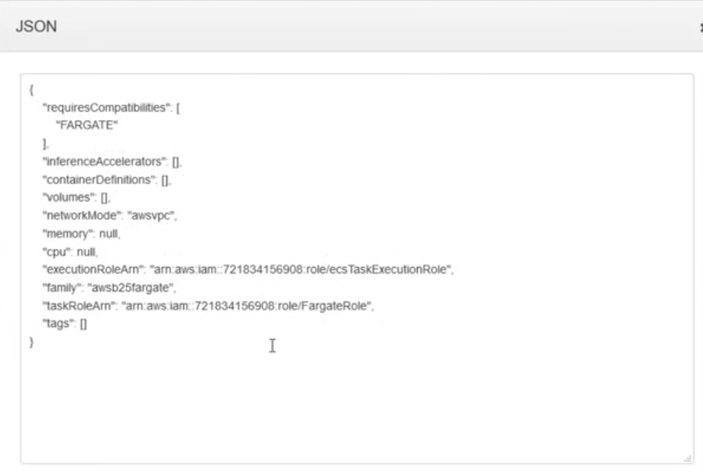

42.

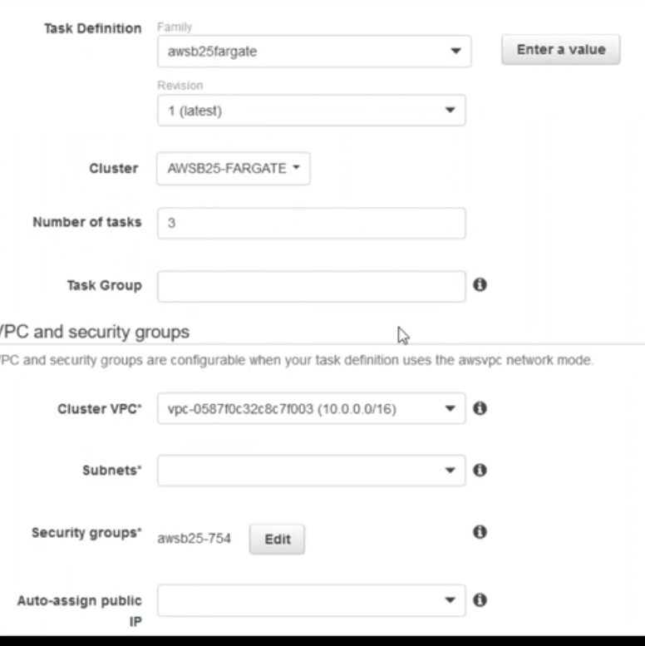

44.how to create service in ecs?

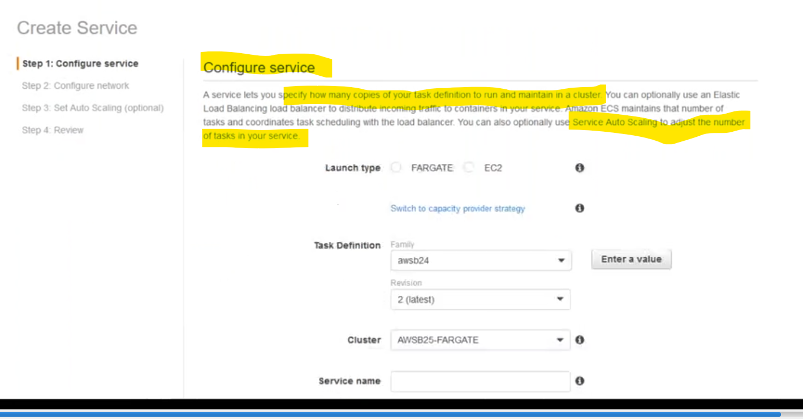

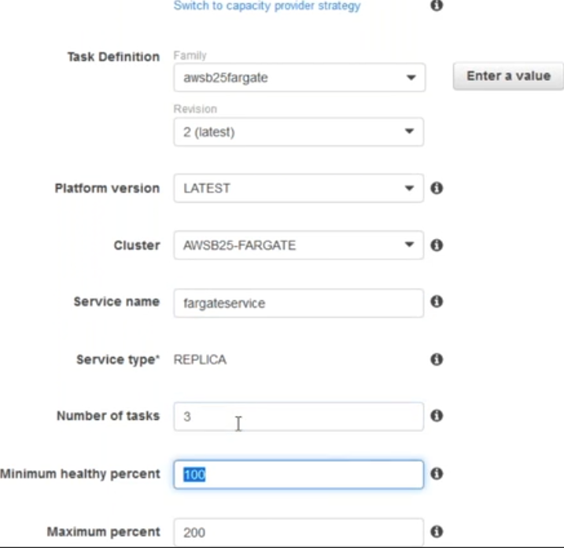

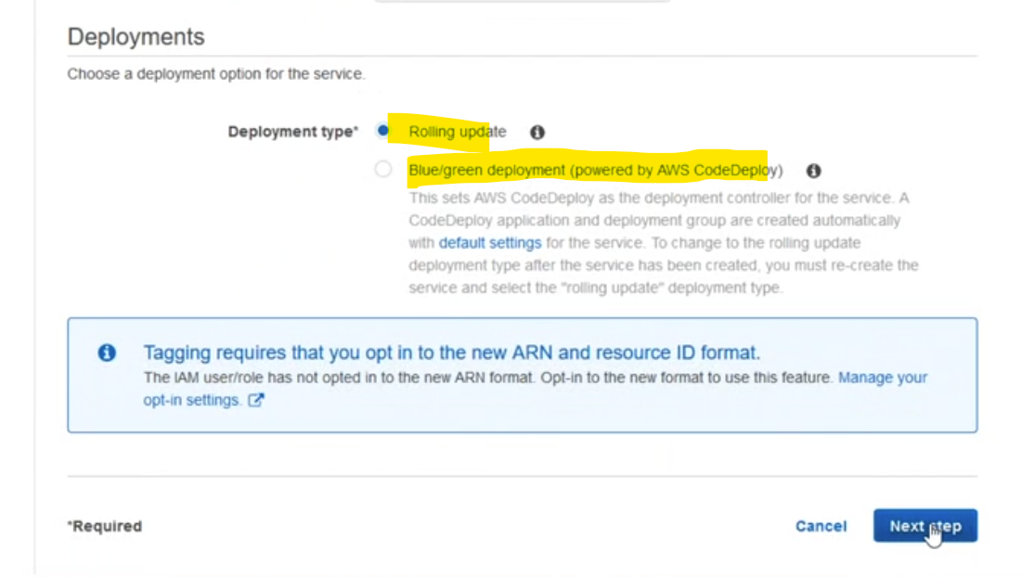

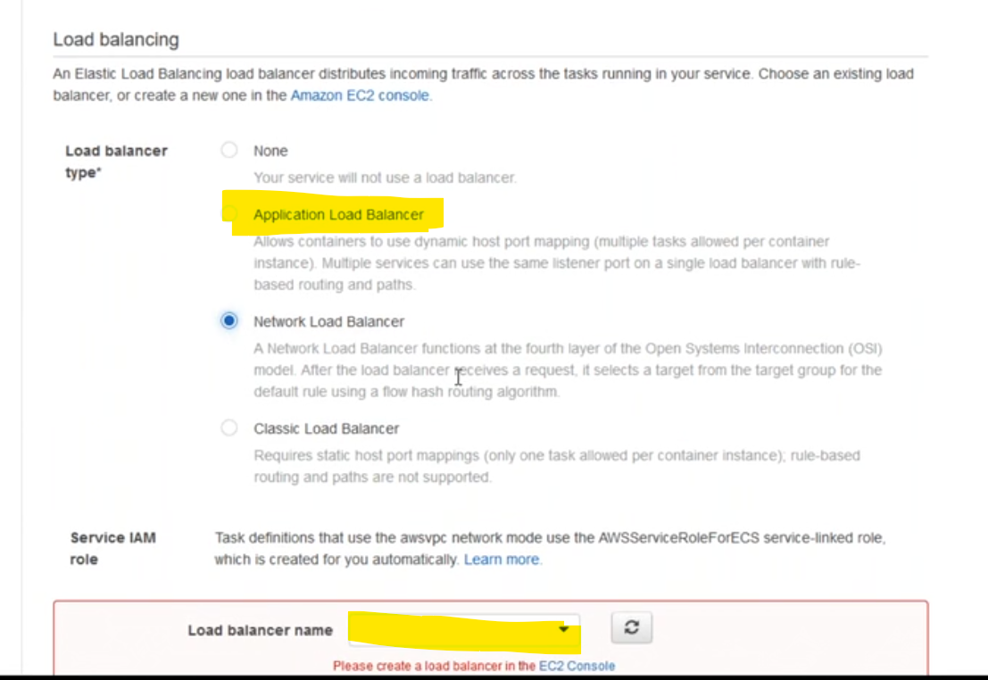

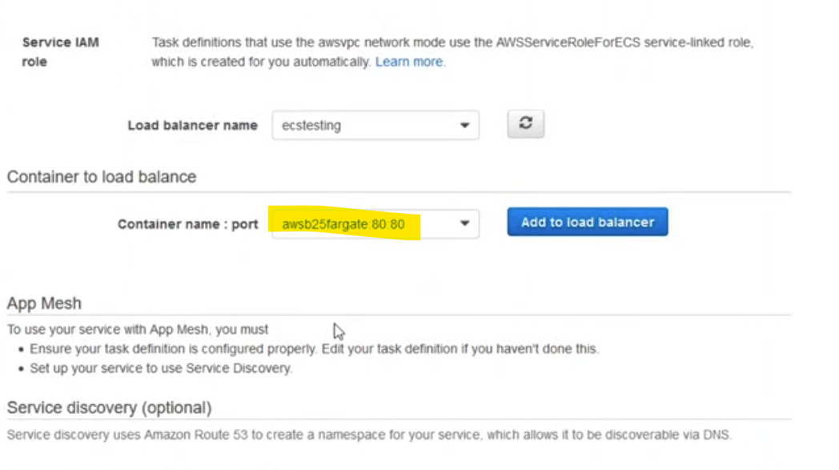

45.

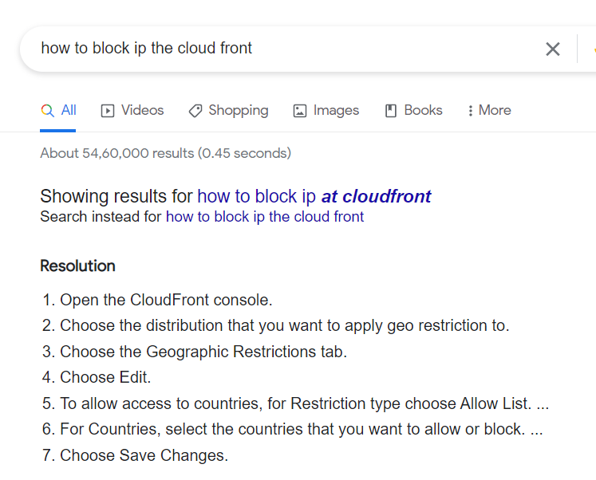

46.

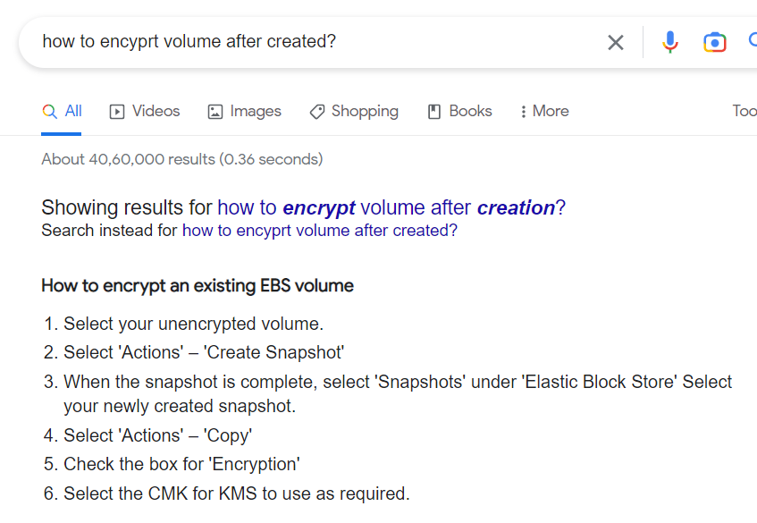

47.how to do disk partition in server&wt are command using?

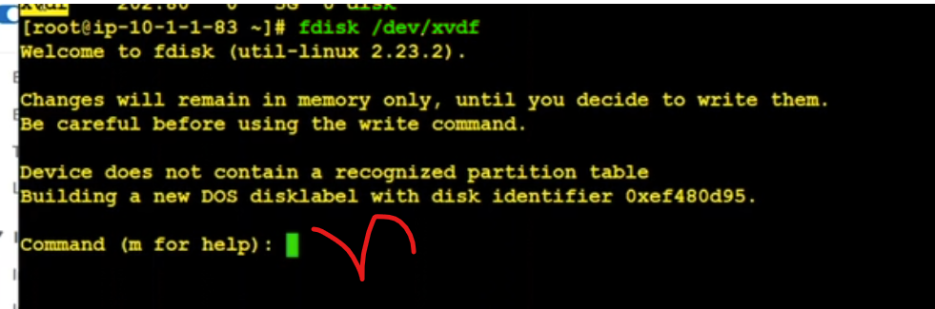

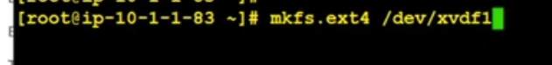

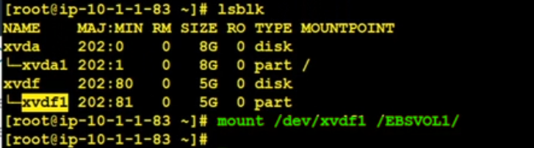

48.how to increase file system  in server?

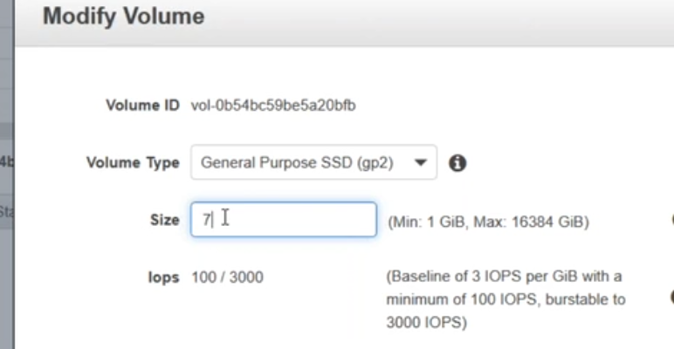

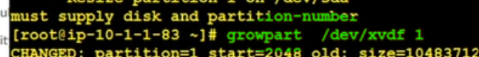

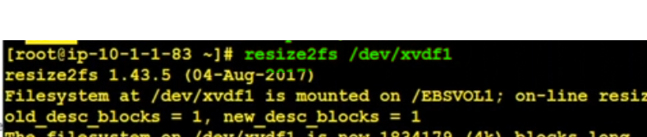

49.wt are storage clases in s3?

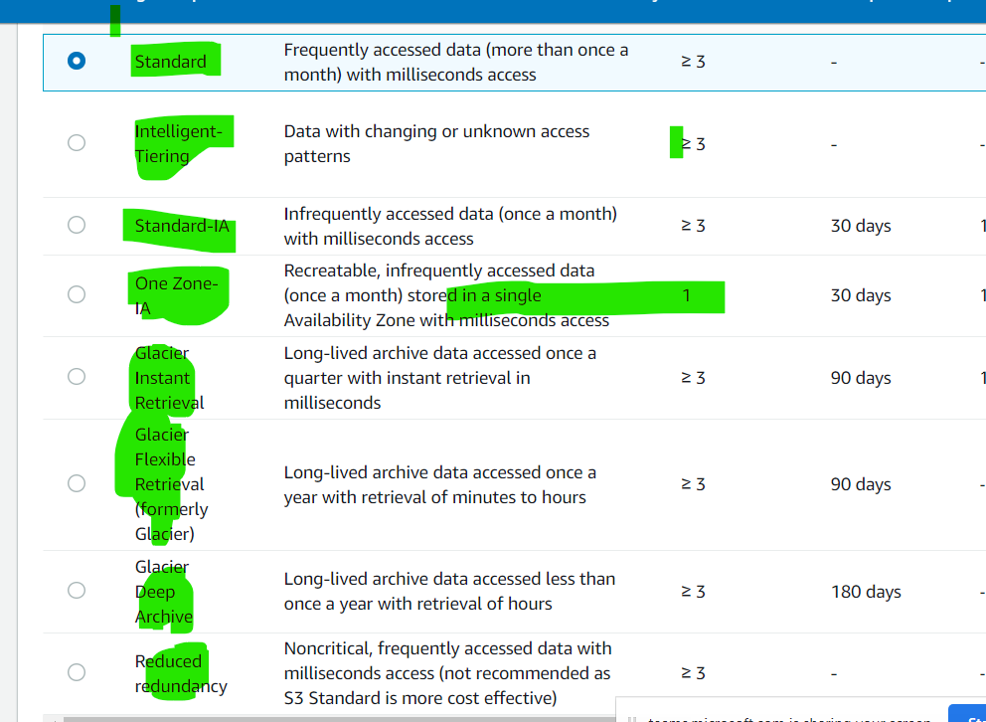

50.wt is diff between the efs vs fsx?

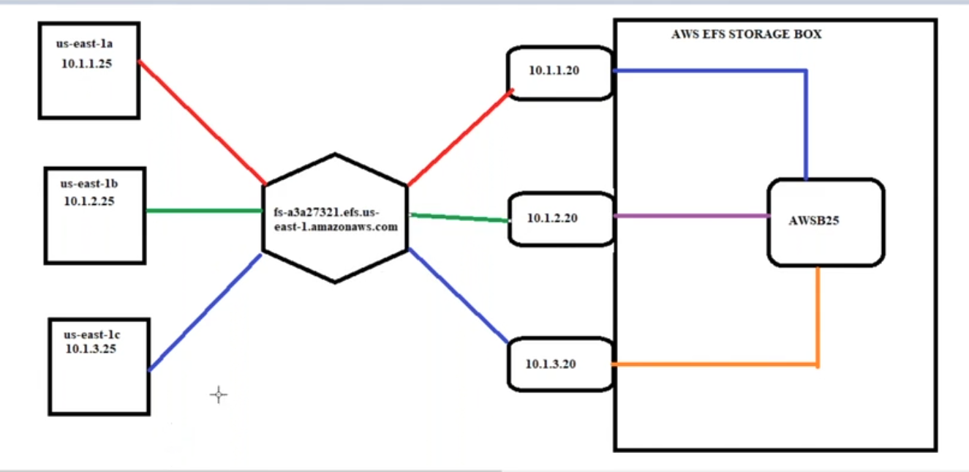

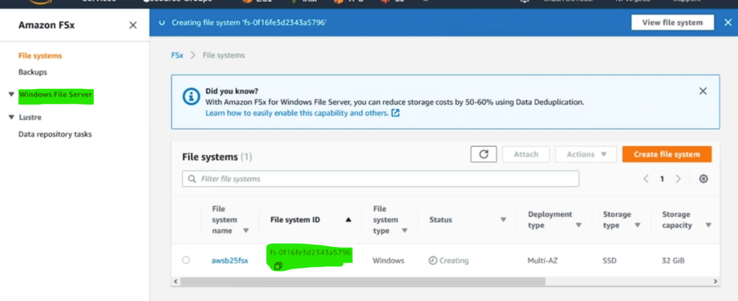

fsx using for windows

efs using for linux

fsx need add active directory for file permission purpose

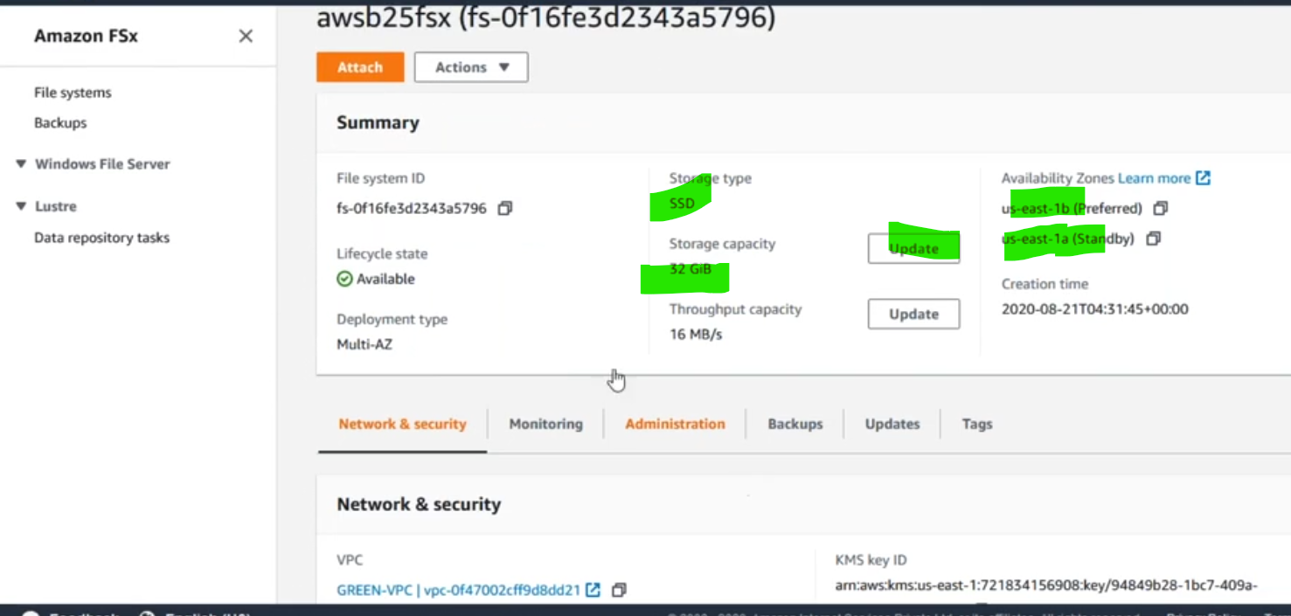

51.wt is use of cloud front?

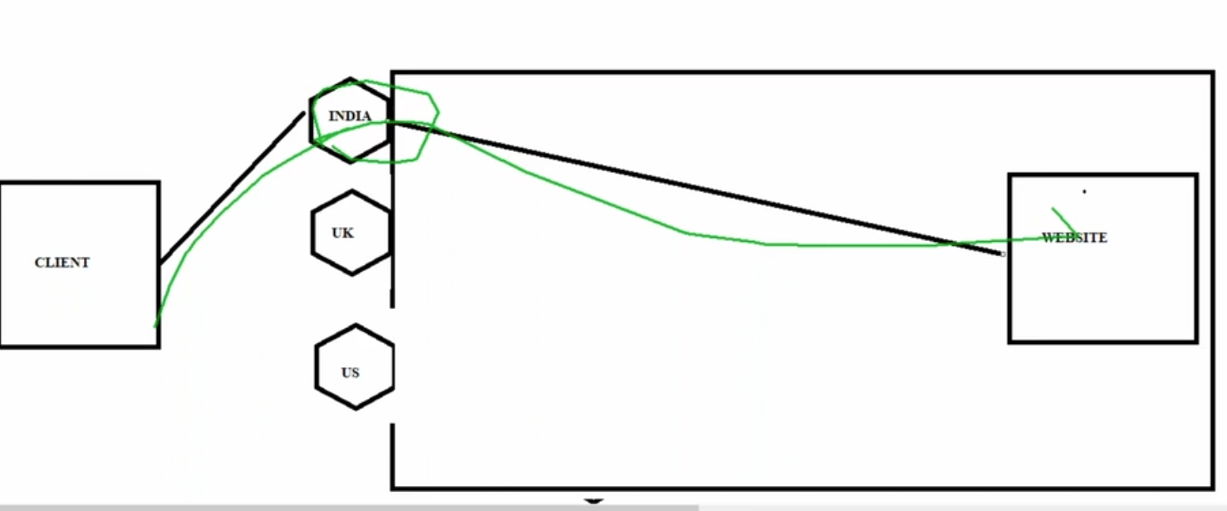

What is CloudFront used for?

Amazon CloudFront is a web service that **speeds up distribution of your static and dynamic web content**, such as . html, . css, . js, and image files, to your users.

52.wt is cdn in aws?

What is CDN and how it works?

A CDN is **a network of servers that distributes content from an “origin” server throughout the world by caching content close to where each end user is accessing the internet via a web-enabled device**. The content they request is first stored on the origin server and is then replicated and stored elsewhere as needed.

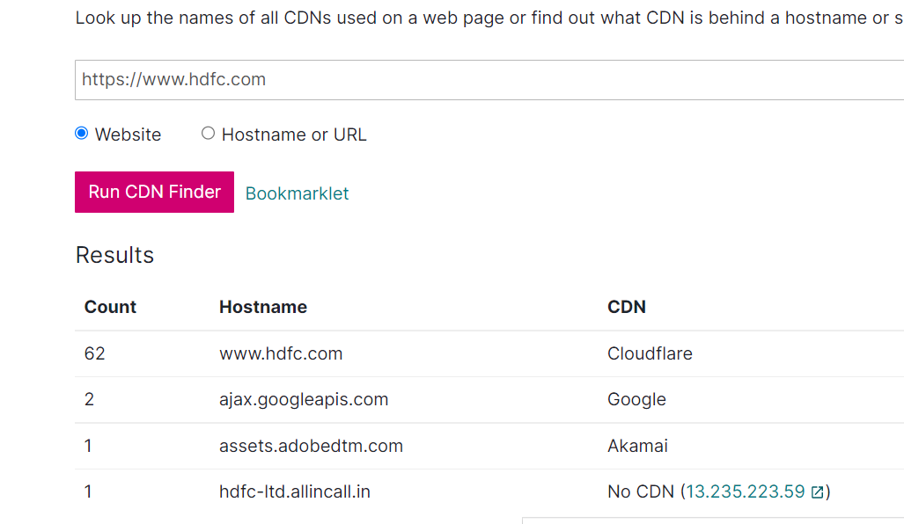

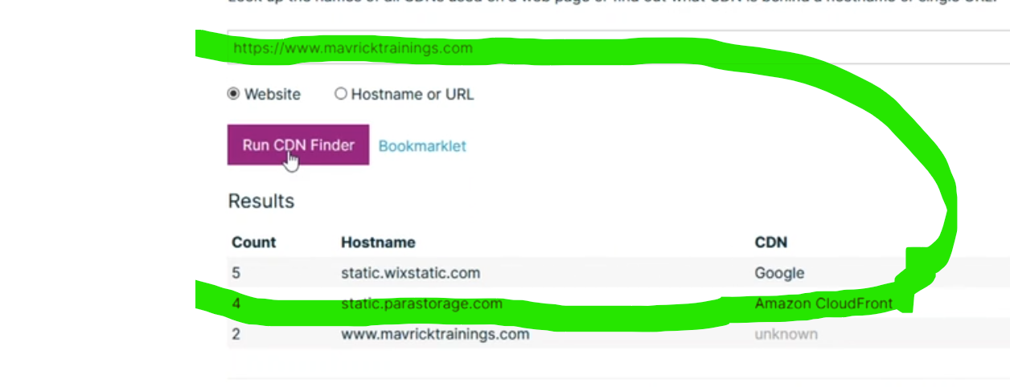

53.wt is alias record in route 53?

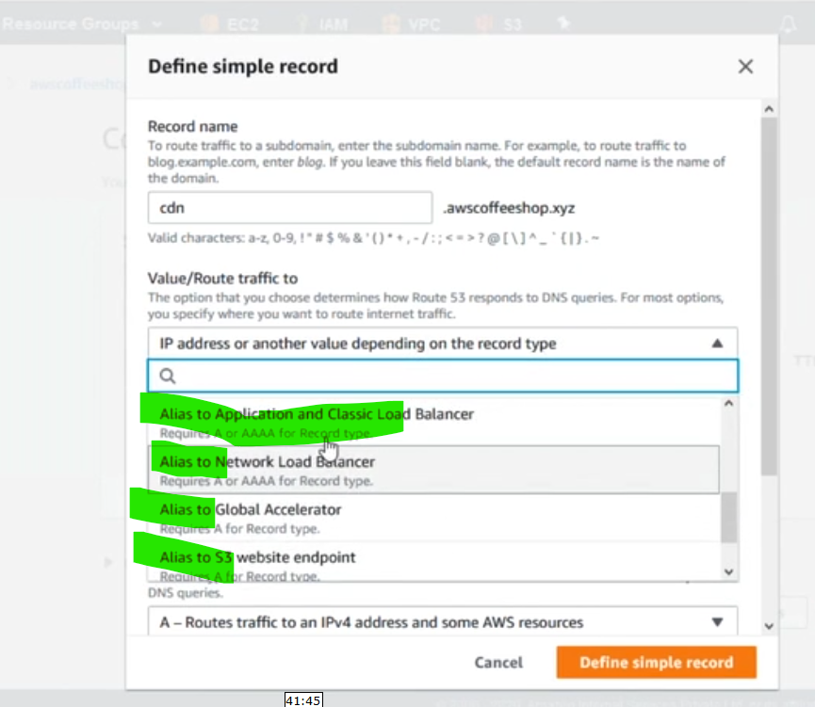

54.wt is sso?

created AD &integrated with ss0 & managed users

What is SSO in AWS?

Posted On: Jul 26, 2022. **AWS Single Sign-On** (AWS SSO) is now AWS IAM Identity Center. It is where you create, or connect, your workforce users once and centrally manage their access to multiple AWS accounts and applications.

55.

What is the purpose of AWS organizations service?

AWS Organizations is an account management service that **lets you consolidate multiple AWS accounts into an organization that you create and centrally manage**. With Organizations, you can create member accounts and invite existing accounts to join your organization.

56.wt is diff between role & policies?

IAM Roles vs. Policies. **IAM Roles manage who has access to your AWS resources, whereas IAM policies control their permissions**. A Role with no Policy attached to it won't have to access any AWS resources.

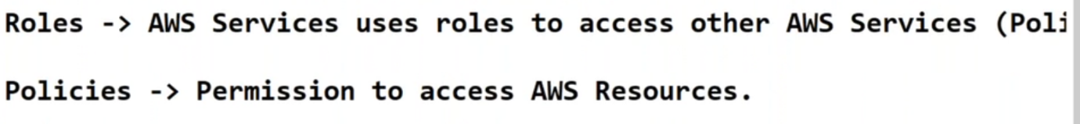

57.wt are type of policies in iam?

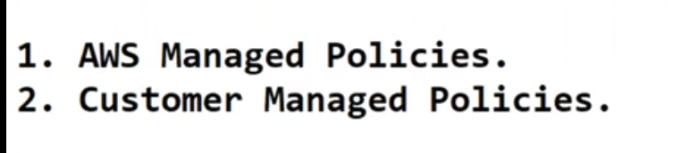

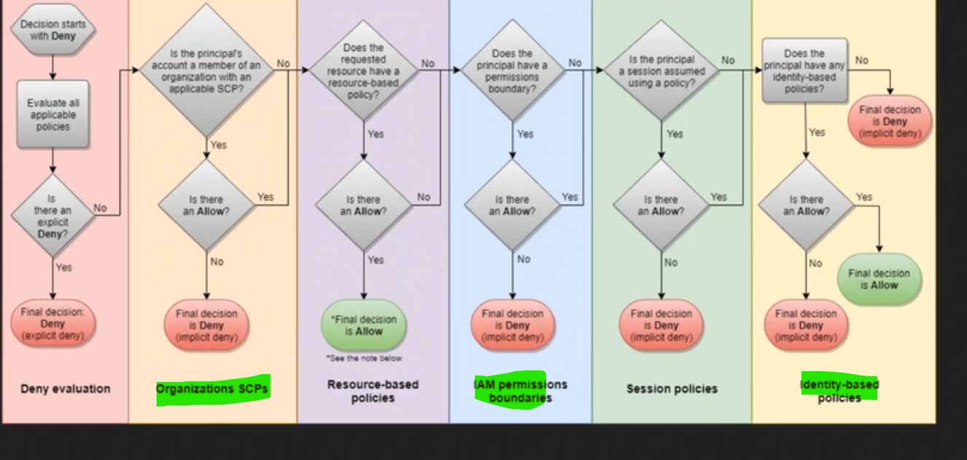

58.how to create policy in ih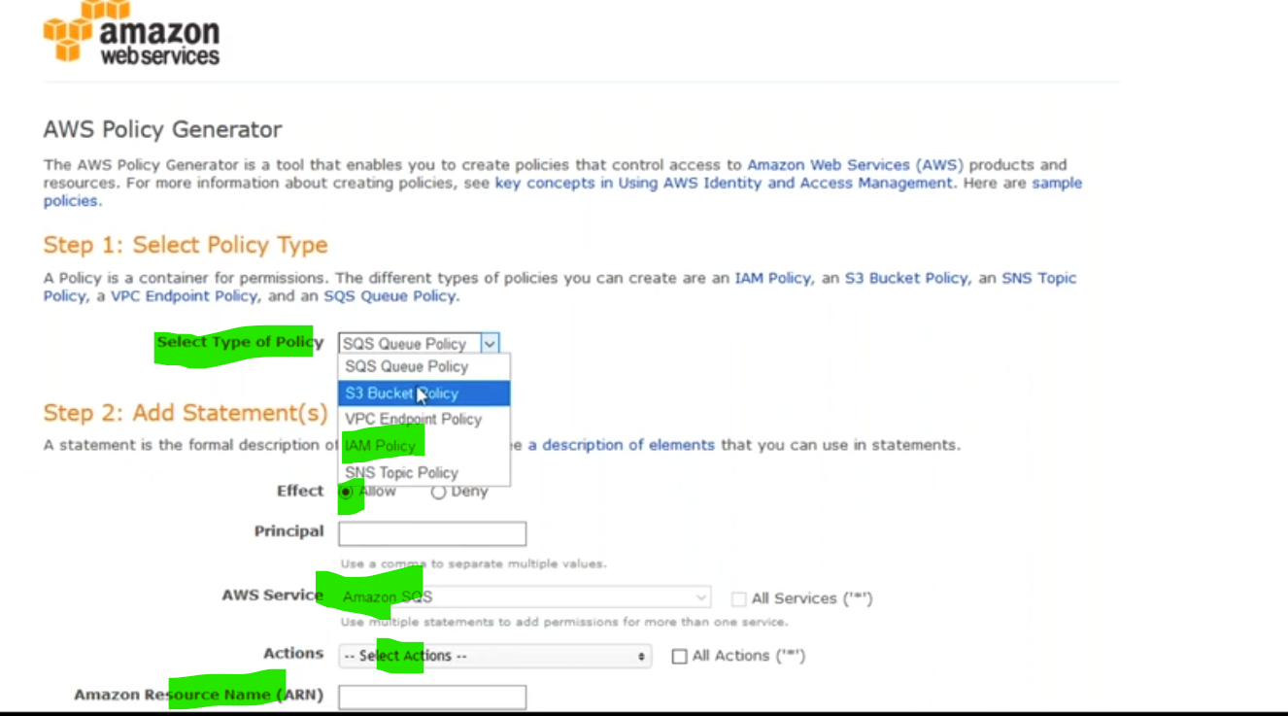





58.

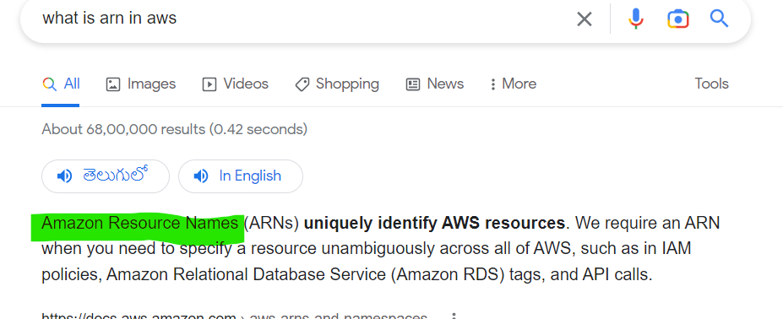

59.

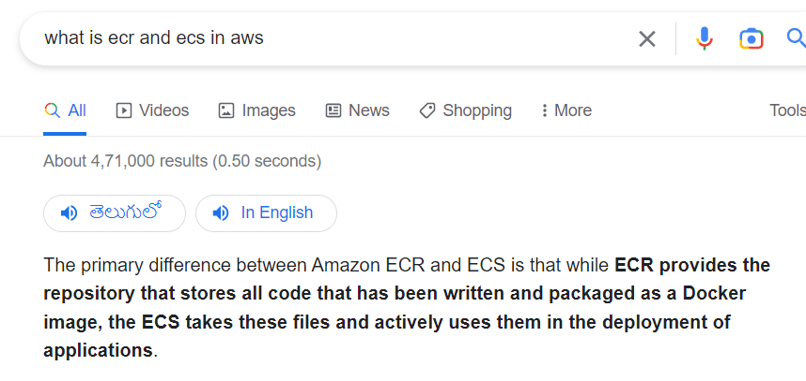

60.how to download s3 bucket in ec2 server?

by using wget command we can download s3url dockuments

wget <https://github.com/kubernetes/kops/releases/download/1.11.0/kops-linux-amd64>

61. how to move files one storage to another storage clases?

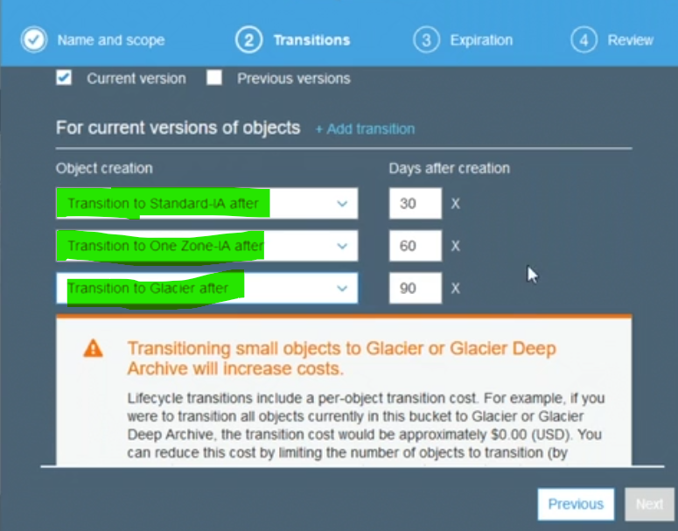

62. wt is versioning in bucket?

Versioning in Amazon S3 is **a means of keeping multiple variants of an object in the same bucket**. You can use the S3 Versioning feature to preserve, retrieve, and restore every version of every object stored in your buckets.

if u unfortunately delete bucket but bucket is available in version

63.

What is the difference between AWS gateway endpoint and interface endpoint?

An interface endpoint is powered by PrivateLink, and uses an elastic network interface (ENI) as an entry point for traffic destined to the service. A gateway endpoint serves as a target for a route in your route table for traffic destined for the service

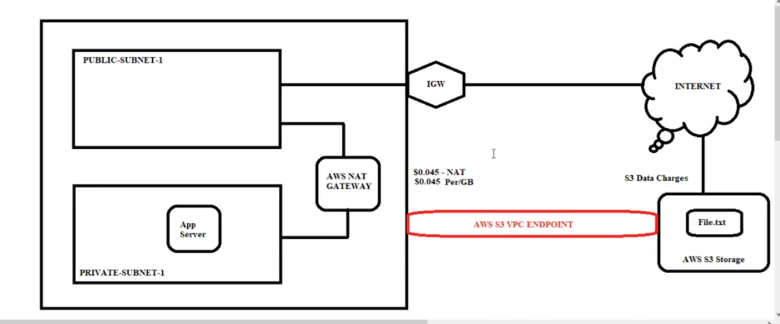

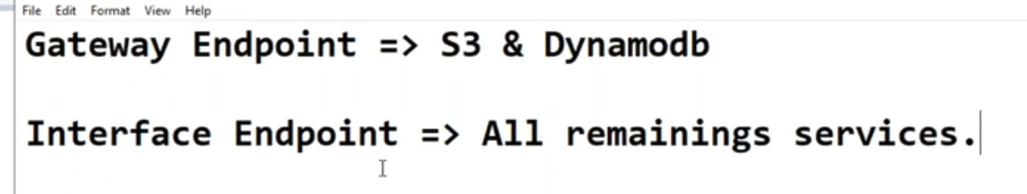

vpc endpoints using for internally download file from s3

**65.**

**How many racks are in a data center?**

**These data centers usually hold anywhere between 1 to 800 racks. Small and mid-sized data centers are driven by the need to make optimum use of their existing data center space. Organizations are shifting to high-density data centers that can serve higher data loads by packing multiple servers in a constrained space.**

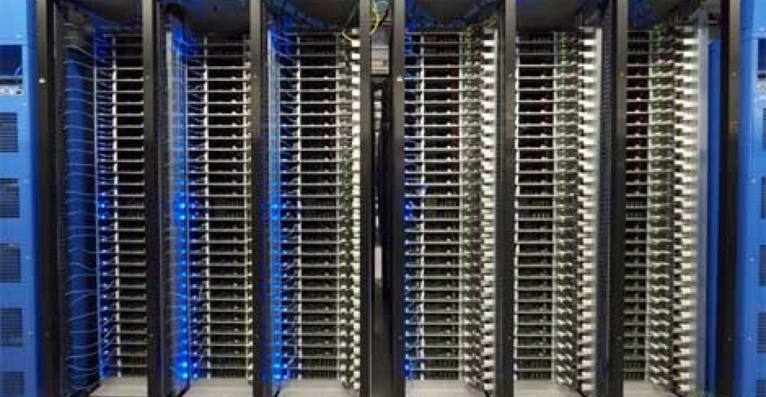

**66**

**How many servers are in a rack?**

**Ordinary servers are usually 3U high, meaning a rack theoretically can hold 14 servers. However, by reducing server height to 2U or 1U, a rack can hold 21 or 42 servers—increasing the processing power by 50% to 100% in the same floor space.**

**S**

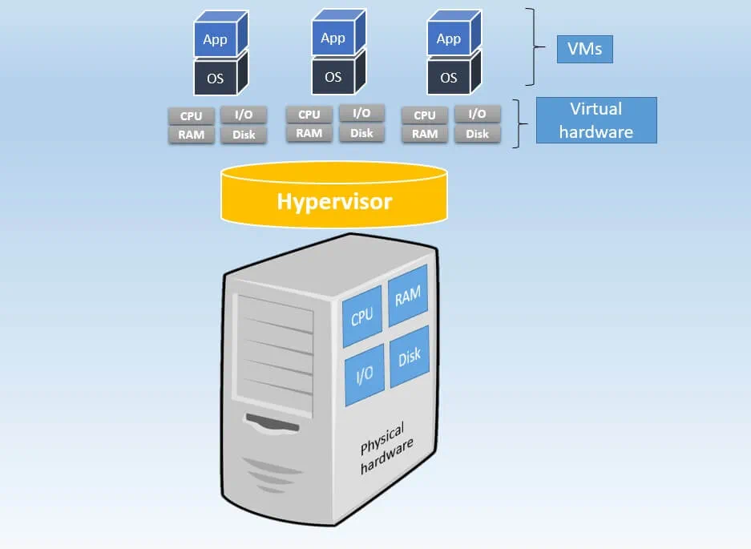

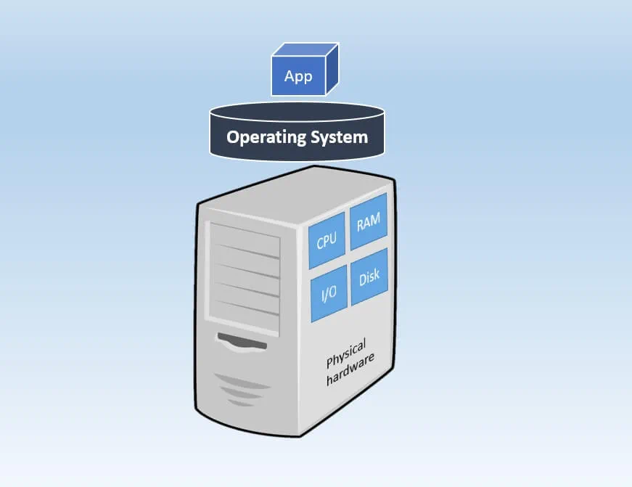

**67.**

**A hypervisor allows one host computer to support multiple guest VMs by virtually sharing its resources, such as memory and processing.**

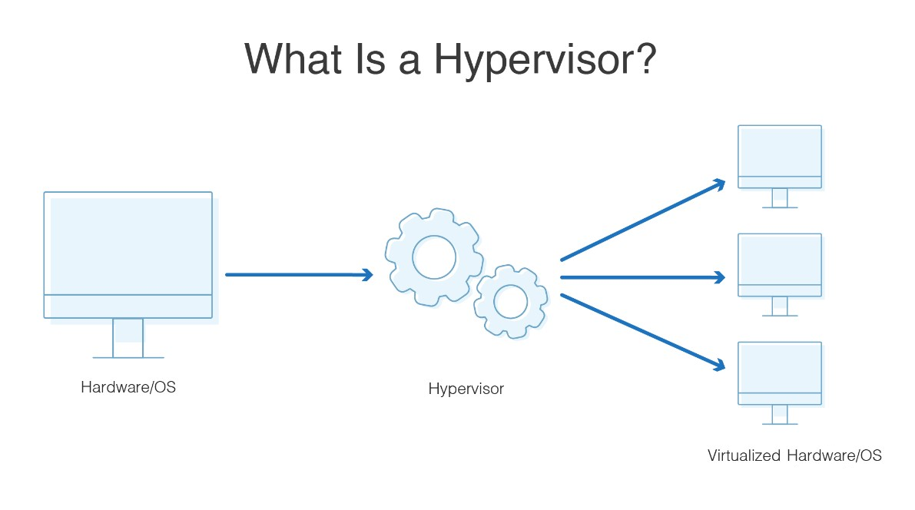

**68**

**wt are type hypervison?**

**Type 2 hypervisor examples include:**

* **VMware Workstation.**
* **VMware Fusion.**
* **Oracle VirtualBox.**
* **Oracle Solaris Zones.**
* **Oracle VM Server for x86.**

**14-Feb-2022**

**69.wt happened in backen role?**

**using access keys & secret key**

**70.wt are the type of policy?**

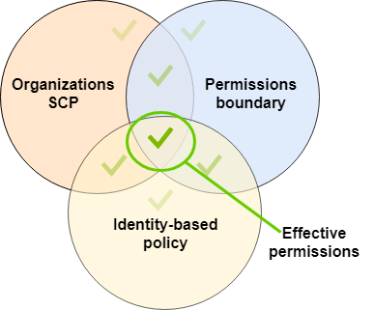

**1.managment policy**

**2.customized policy?**

**71.wt is use case of permission boundary in iam?**

**What is permission boundary in IAM?**

**A permissions boundary is an advanced feature for using a managed policy to set the maximum permissions that an identity-based policy can grant to an IAM entity. An entity's permissions boundary allows it to perform only the actions that are allowed by both its identity-based policies and its permissions boundaries.**

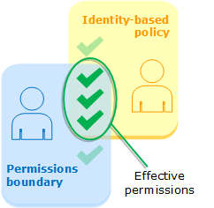

**72.what is aws organisation ? how to manage?**

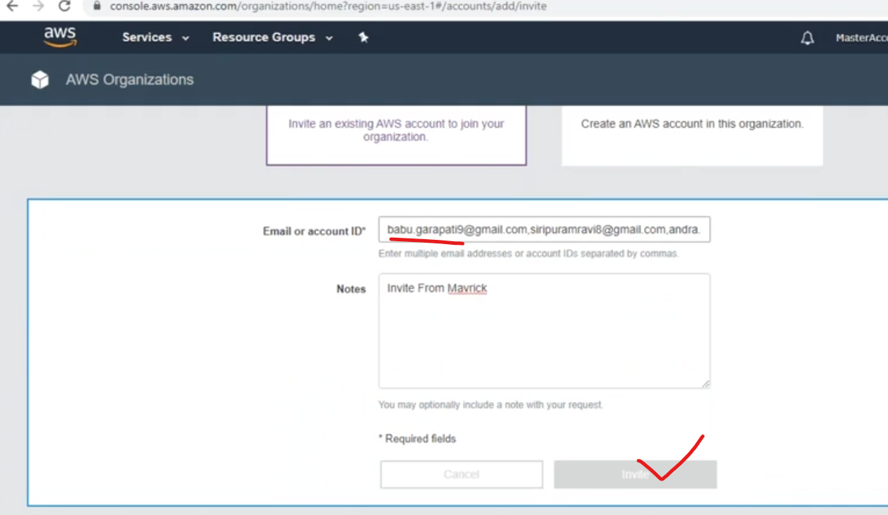

**-73.wt is scp in aws?**

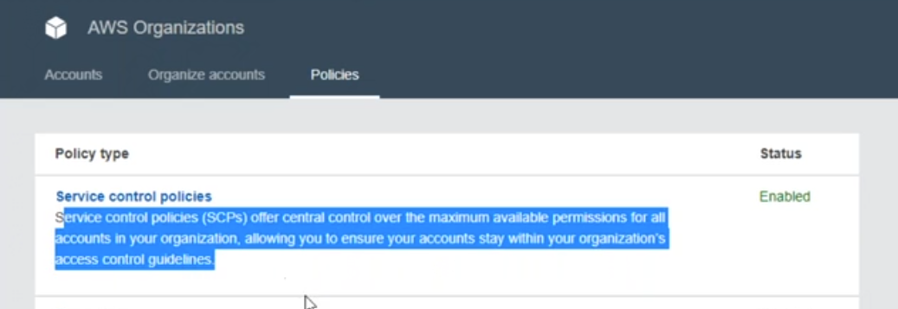

74.

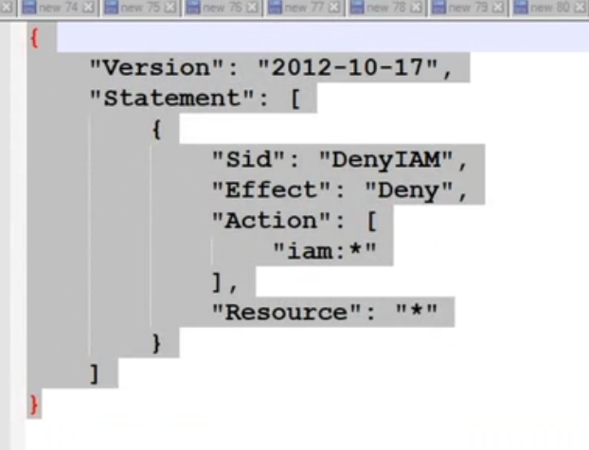

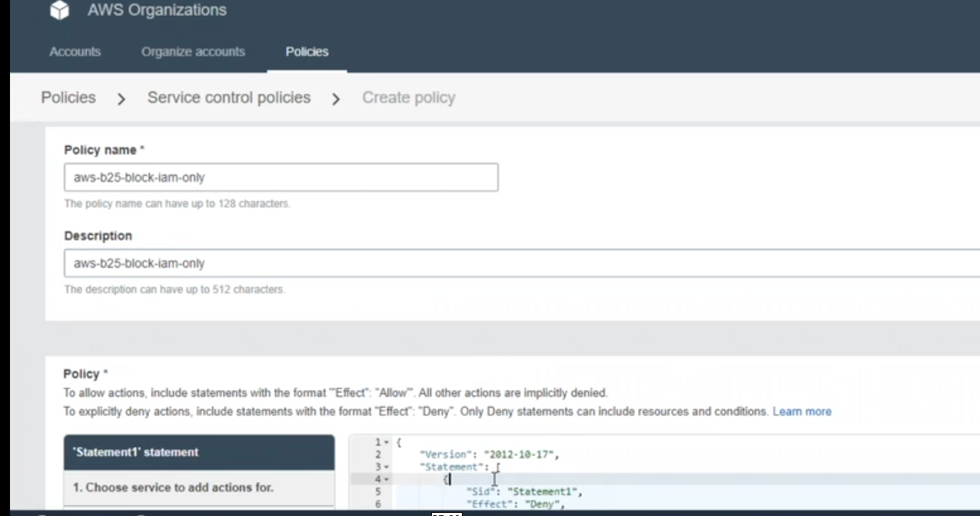

75.wt is diff between the costmized ami vs ami?

77.

which vpn connect to our office location 0r our project machine?\

CISCO VPN CONNECT

78.WT is diff between the instance store & ebs stosrage?

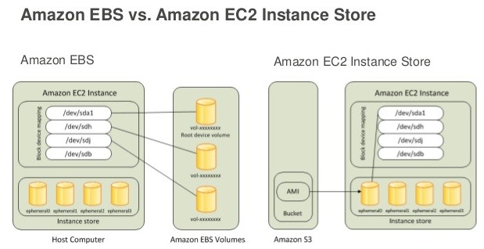

81.What is AWS hub and spoke model?

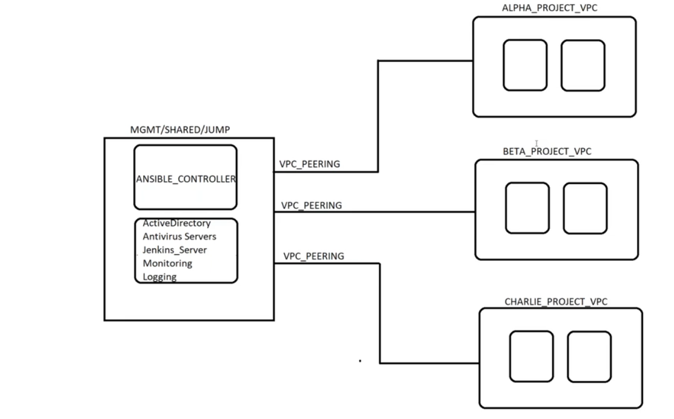

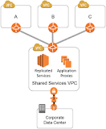

What is the Hub-Spoke Model? The hub-spoke model, sometimes called the “shared services” model, **relies on VPC Peering connections between the hub VPC and each spoke VPC**. Each spoke VPC usually contains different SDLC tiers (Dev, Test, Stage, Prod)

79.wt type of t2 series in ec2?

t2 ios general purpose instances

c types compute optimize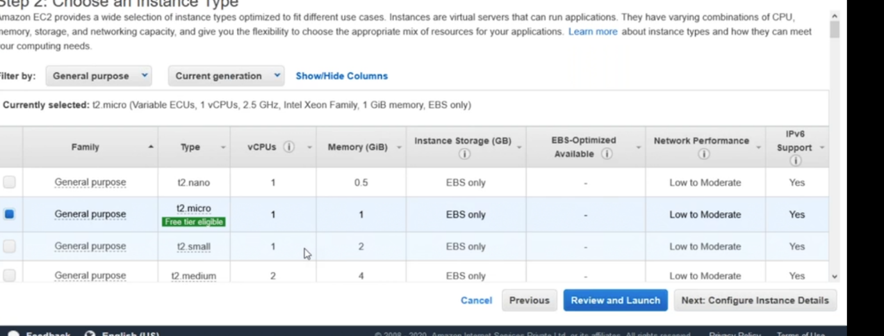

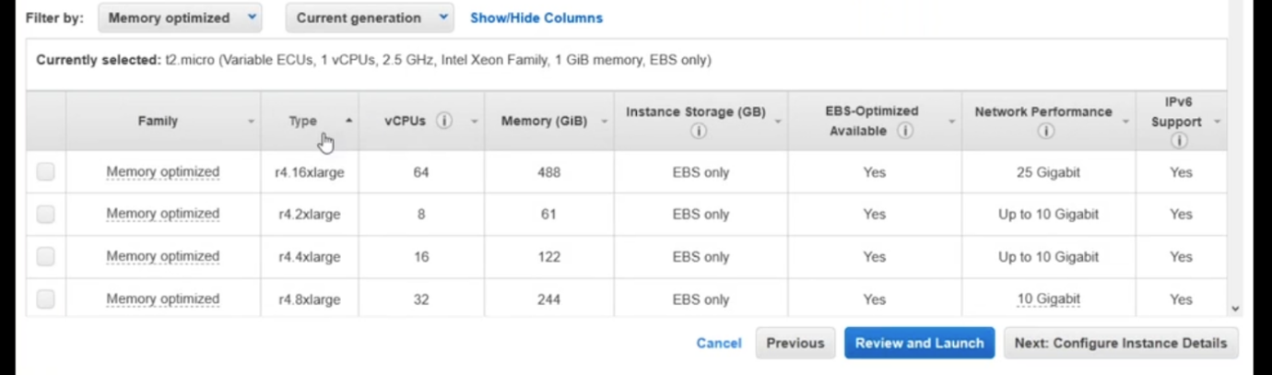

**80.how to start troubleshooting when server goes down**

**When a server goes down, it can be a stressful situation, but there are a few steps you can take to troubleshoot the issue and get the server back online as quickly as possible. Here are some general steps to follow when troubleshooting a down server:**

1. **Check the status of the server: Use tools such as ping, traceroute, or telnet to check the status of the server and determine if it is reachable on the network.**
2. **Check the system logs: Review the system logs for any error messages or warning signs that may indicate the cause of the problem.**
3. **Check the system resources: Use tools such as top, free, or vmstat to check the system resources, such as CPU, memory, and disk usage, to see if the server is experiencing a resource bottleneck.**
4. **Check the network connections: Use tools such as netstat or lsof to check the network connections and see if there are any unusual connections or if the server is experiencing a network bottleneck.**
5. **Check the application status: If the server is running an application, check the status of the application and see if it is running correctly. Look for any error messages or warning signs that may indicate the cause of the problem.**
6. **Check the hardware: If all the above steps do not show any issue, check if there is any issue with the hardware of the server, such as overhe**